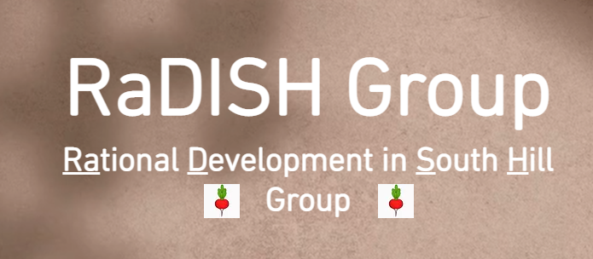

Dear Neighbour,

We are writing to you about a development proposal in your neighbourhood. A group of developers have filed a proposal with the City to tear down a church and adjacent buildings at 175-195 St. Clair West to erect a Vegas-sized tower complex. The behemoth 15-storey development will add over 200 cars, remove trees and green space, cover a park in shadow, create new traffic hazards, and negatively impact surrounding hydro, water, wired/wireless and sewage infrastructure. Not surprisingly, it fails to comply with the applicable City Plan building limits and other legal parameters in many respects.

We have sought to bring the relevant issues to your attention, but, so far, related dialogue has been carefully controlled and limited by the developers. That will change this Wednesday, March 23, when the City will host a virtual Community Consultation Meeting to review the proposal. City Planning staff have table a preliminary report raising certain issues with the proposal, but in many respects have stayed silent, awaiting input from the community on its views on the impact of the proposed development. Depending on what they hear at the meeting and their subsequent analysis, City Planning staff will prepare a final report and recommendation to be tabled at City Council that will critically impact the path takes moving forward.

We are a group of neighbourhood residents advocating smart development of our community. We recognize the need for change and support the growth of the City. However, we think City Plans are development principles need to be heeded, not ignored, and that this proposed development will have a very negative impact on us all. If permitted, it will also set a precedent for future buildings throughout the neighbourhood, perhaps one next to you.

If you care about your home, your neighbourhood and your City, we want to hear from you – and we think City Planning Staff, as well as the developers and their team of lawyers, consultants and experts who are seeking to justify why they don’t have to abide by the City Plan and applicable laws need to hear from you as well.

Please join us via at the virtual Community Consultation Meeting at 6:30, Wednesday March 23, so that your voice can be heard. See our website at [**www.radishgroup.net**](http://www.radishgroup.net)to get the link to register for the session. Visit this site to contact us, show your support, gain further information, make a donation, register your views or speak to one of our group.

We want to hear from you.